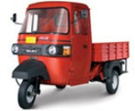

GC MAX Diesel

[KEY FEATURES](http://www.bajajauto.com/comm_goods_gcmax_diesel.asp) TECHNICAL SPECS [MY BUSINESS OPPORTUNITY](http://www.bajajauto.com/comm_goods_gcmaxd_bussiness.asp)

TECHNICAL SPECS

Engine

* Type: Four Stroke, Forced Air & Oil Cooled, Compression Ignition Engine
* Capacity : 416.6cc
* Compression Ratio: '24:1
* Max power : 8.5bhp@3400rpm
* Max torque : 20Nm @2600rpm

Transmission

* Clutch : Single Plate, Dry , Foot Operated
* No. of Gears : 4 Forward, 1 Reverse

Chassis

* Type : Monocoque with Stamped & Welded Member

Suspension

* Front :Twin Shock Absorber with Helical Coil Compression Spring & Antidive Link
* Rear : Shock Absorbers with Helical Coil Compression Spring & Trailing Arm

Tyre

* '4.50-10,8PR for Front & Rear

Brakes

* Drum Brakes ,Auto Adjustable, Foot Operated with Tandem Master Cylinder

Electrical

* System Voltage : 12V , DC
* Battary Rating : 12V,50Ah

Fuel Tank

* Material : Plastic
* Capacity : 12 lit

Dimensions

* Wheel Base 2025mm
* Overall Width 1478mm
* Overall Length : 2960mm
* Overall Height : 2070mm
* Min Ground Clearance : 170mm

Weights

* GVW : 990kg
* Kerb Weight : 425kg

KEY FEATURES

Image

* **Feature**

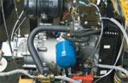Powered by Japanese Kubota Diesel Engine

**Advantage**

Peak Torque & Power at low engine rpm. Oil & Air Cooling of the Engine. Triple Vortex Combustion. Electronic Fuel Pump. Warning Indication for Air Filter Clogging  
and Oil Pressure Drop.

**Benefit**

* Best Load Pulling Ability in the Segment Very Good Mileage & Almost Nil Manitenance.

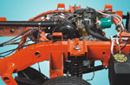**Feature**: Rugged Chassis & Robust Aggregates

**Advantage**: Super Tough Ladder Chassis can Bear Abuse of Loads & Roads

**Benefit:** Confidence to Carry More Loads with Least Wear & Tear.



**Feature:** 12+12 Month Warranty

**Advantage:** GC Max Reliability;BAJAJ Promise.

**Benefit:** Hassle Free Business.

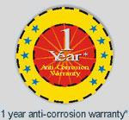

**Feature**: Catholic Electro Deposition Paint Process

**Advantage:** Anti Corrosion Coating on Body Panels before Painting which Prevents Corrosion of Body Parts.

**Benefit** :1 Year Anti-Corrosion Warranty

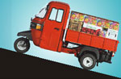Feature: Wheelbase of 2025mm, which is the highest in its category. Lowest rear overhang- 34% of Wheelbase.

Advantage: No Chance of Vehicle Front Lifting During Loaded Drives on Upslopes.

Benefit: Drive with Confidence with any Load on any Road Surface. No Front Lifting

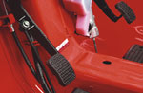

Feature : Single Plate Diaphragm Clutch with Foot Actuation

Advantage : Longer life of clutch

Benefit: Low Maintenance Cost.

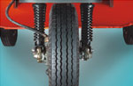Feature: Twin Front Suspension with Antidive Link

Advantage:Effective Vibration Damping and Smoother Ride

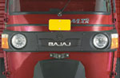Better Manouverability   
 Benefit: Road Grip in Rough Terrains.

Feature: Twin Halogen Headlamp with Multi Focal Reflector

Advantage: 30% More Brightness and Visibility than Ordinary Bulbs

Benefit: Safe Driving in the Dark.